***Data Analytics***

**Case Study: Analysis of Medical Premium charges for insurers**

**Data Refinary**

* Descriptive analytics of data

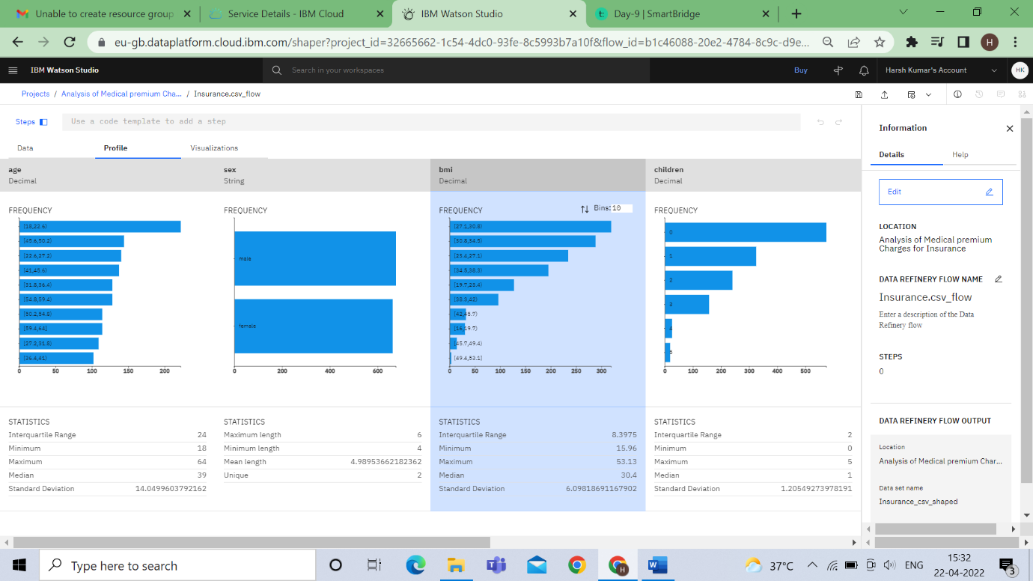

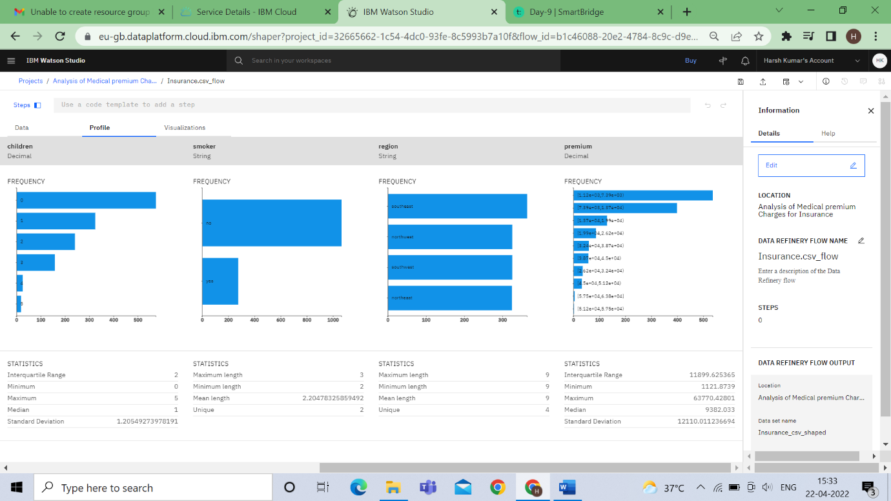

* Exploratory Analytics

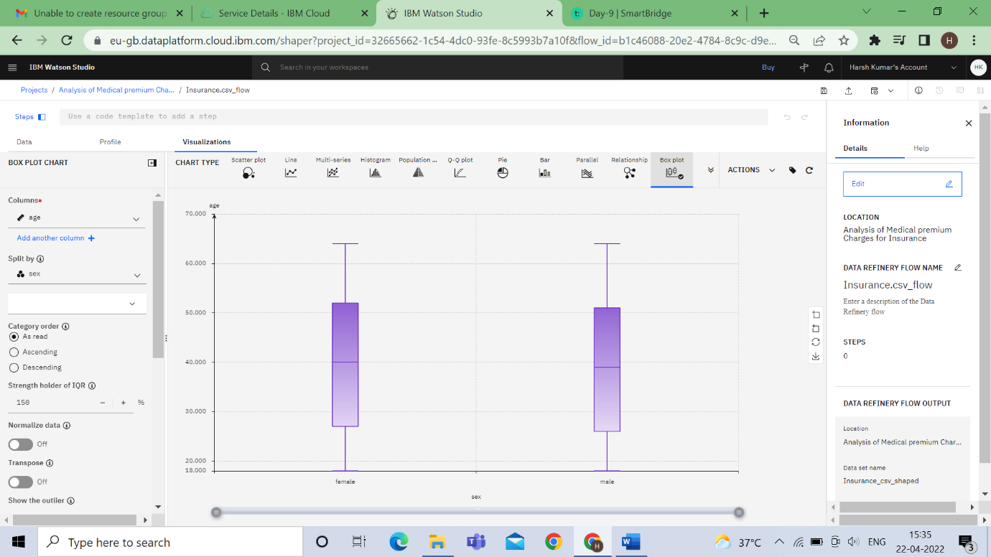

Columns-age ,split by-sex

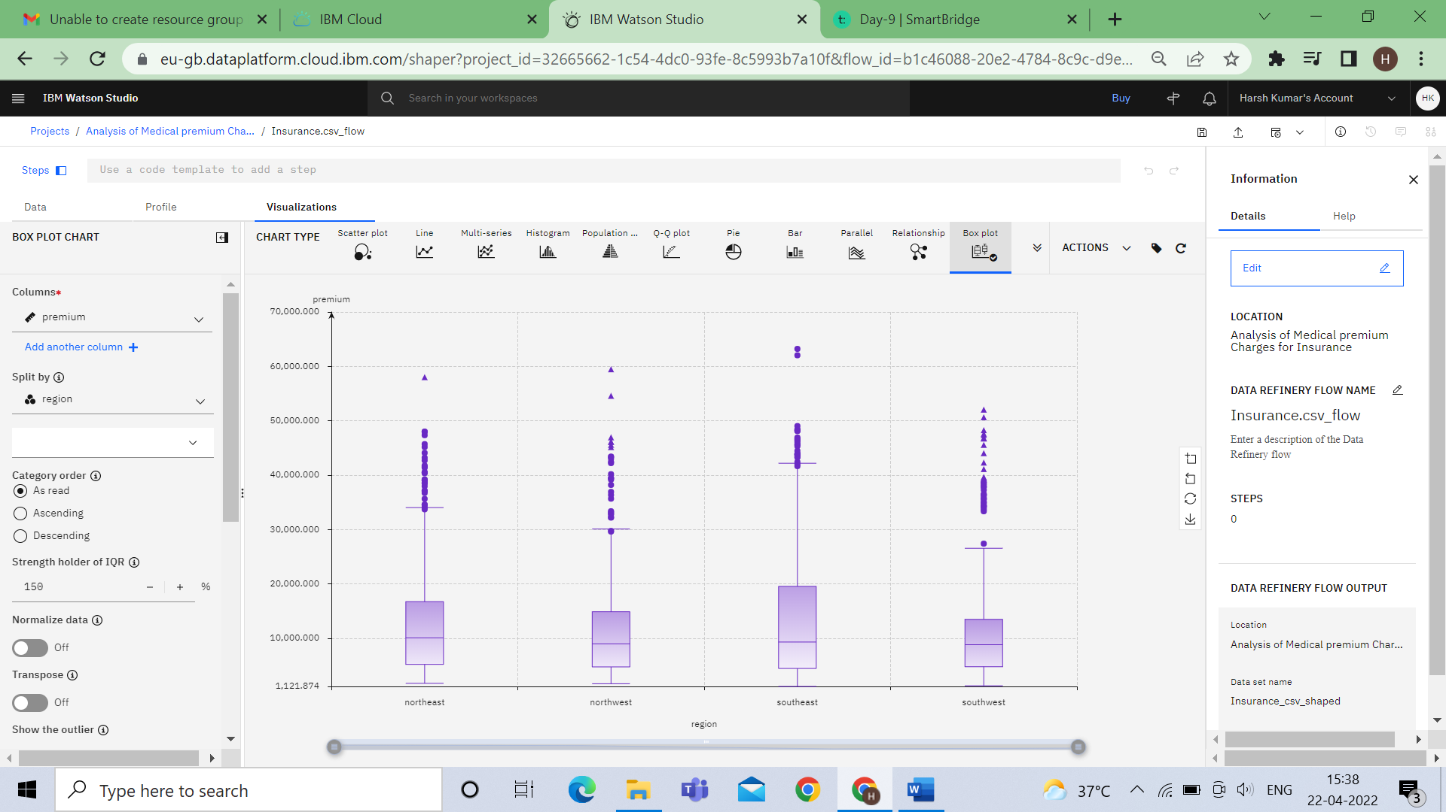

Columns-premium ,split by-resion

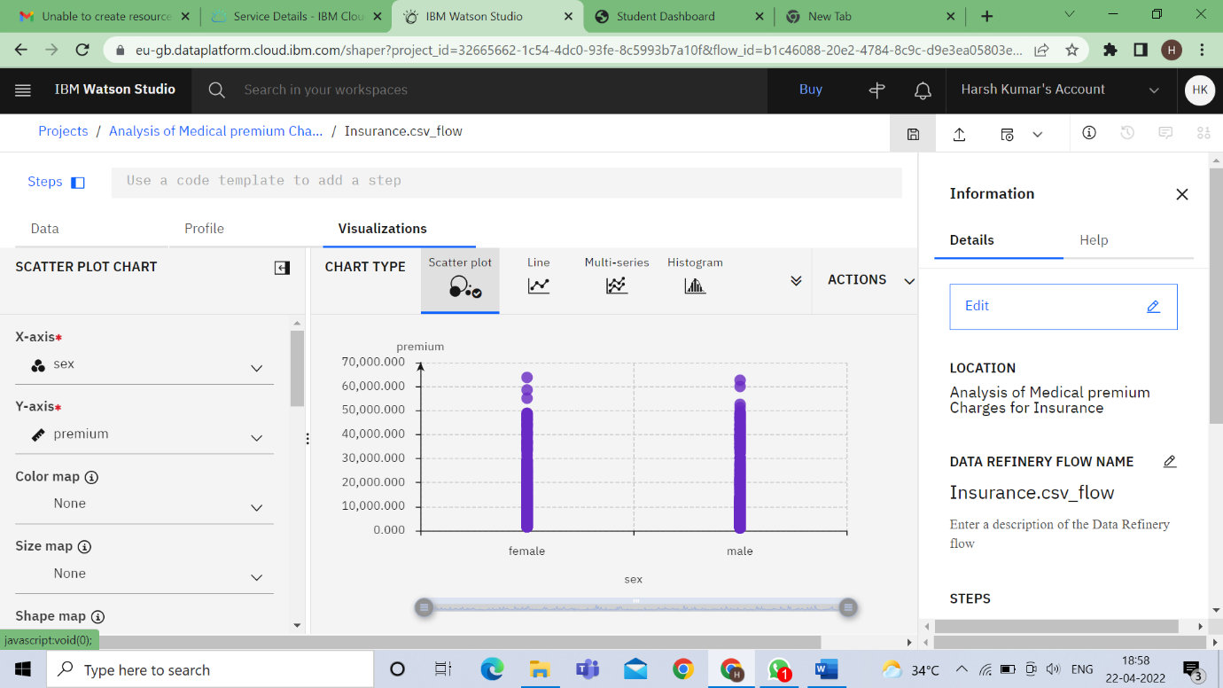

**X-axis = sex , Y-axis = Premium**

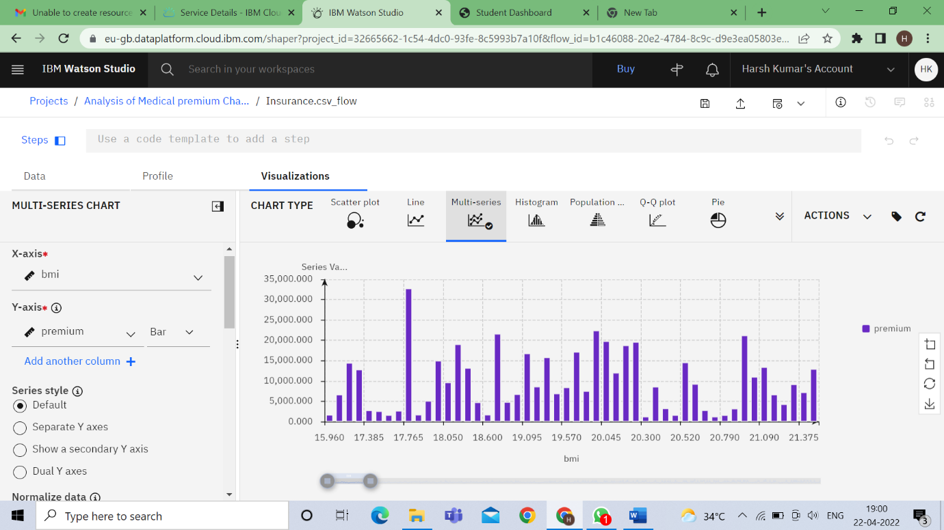

**X-axis = bmi , Y-axis = Premium**

**2.SPSS Modeler**

* **Model**

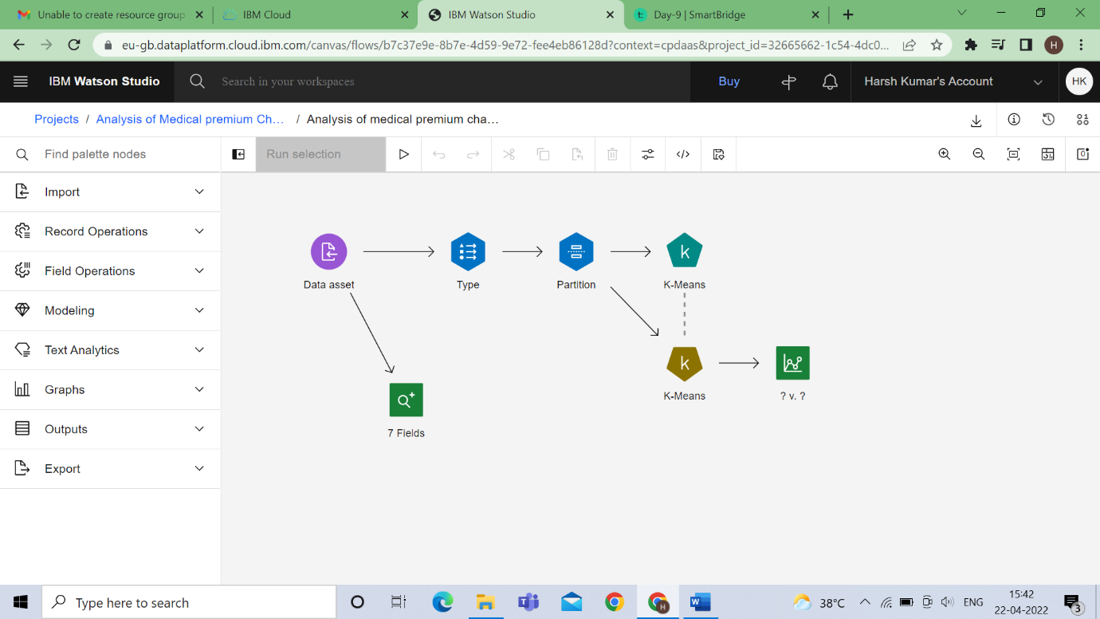

* **Type node**

**BMI as none**

**premium as Output or target**

**other as input**

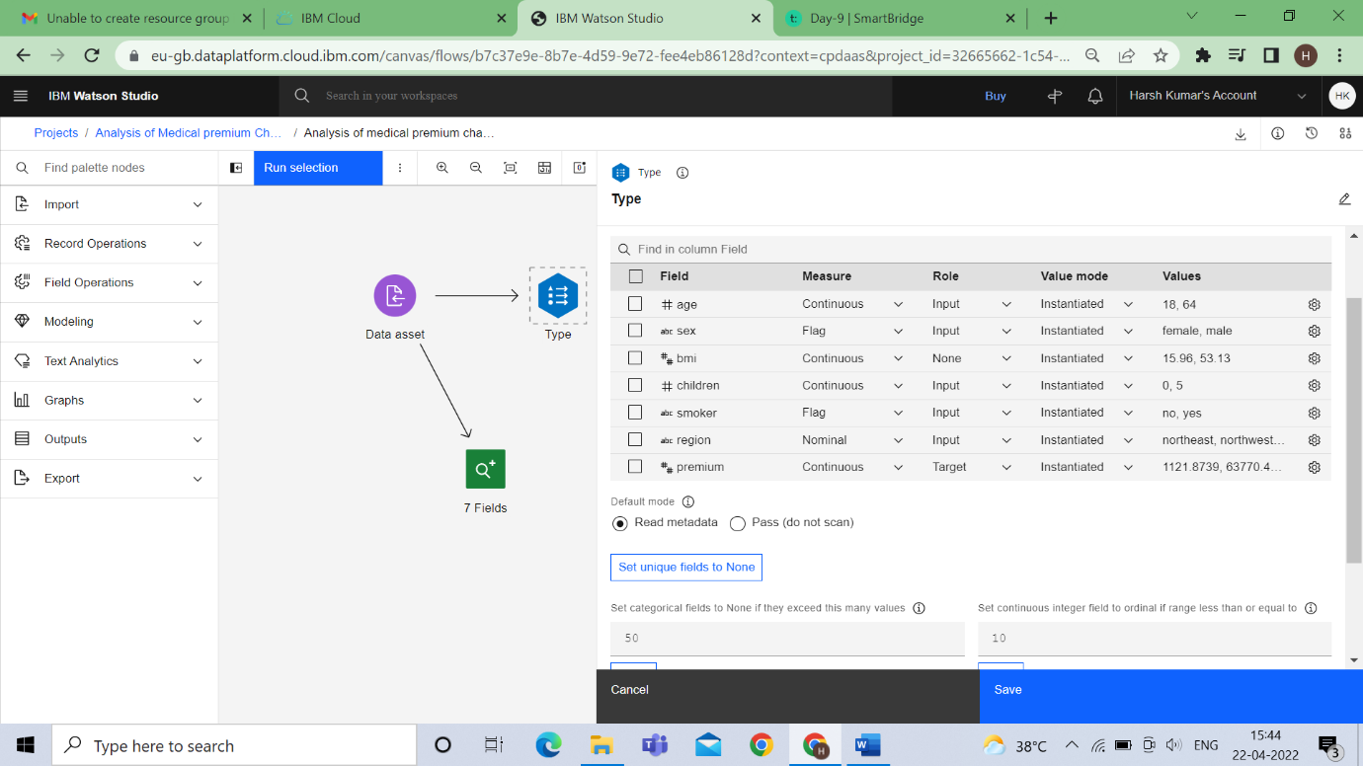

* **Partition node**

**Training – 70%**

**Testing – 30%**

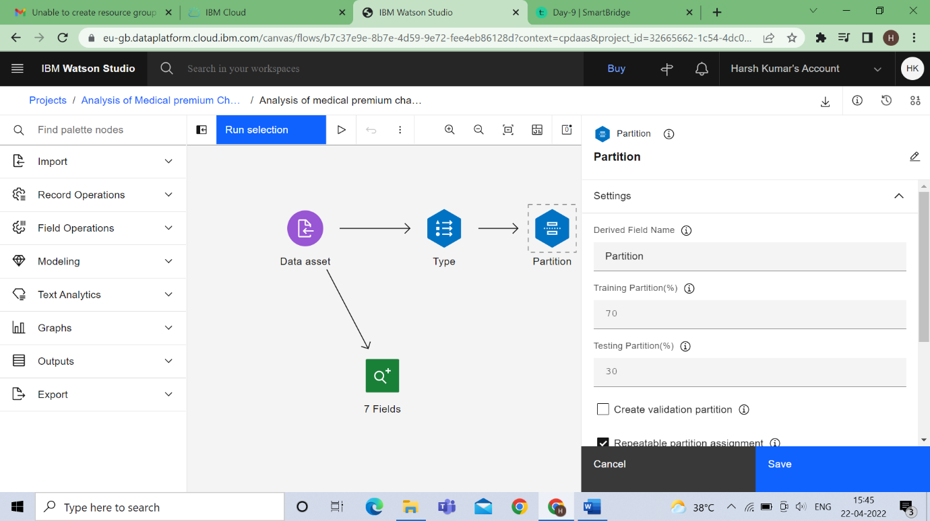

* **Model**



* **Output**

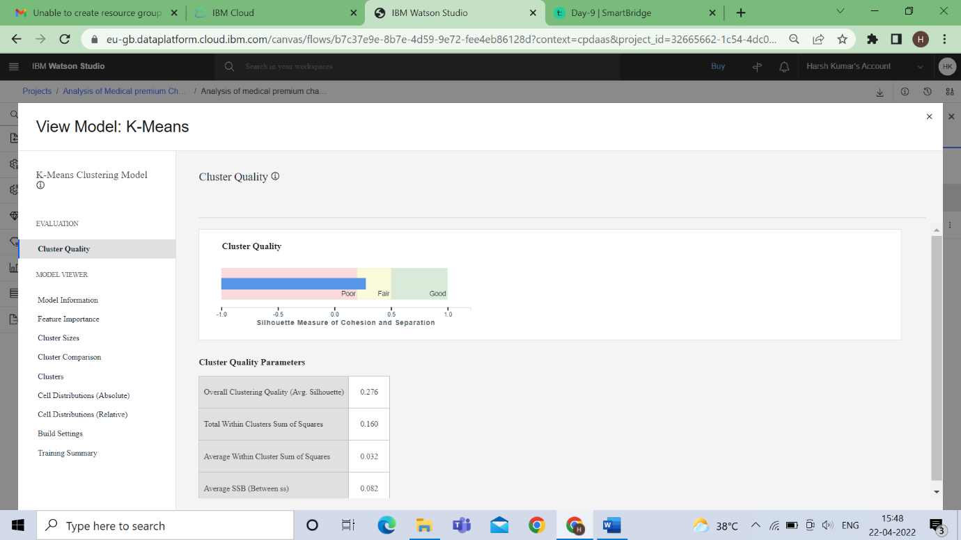

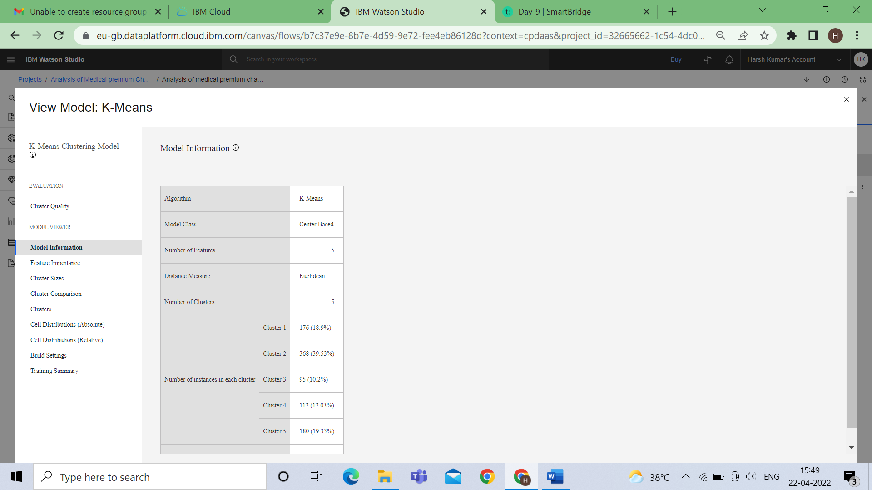

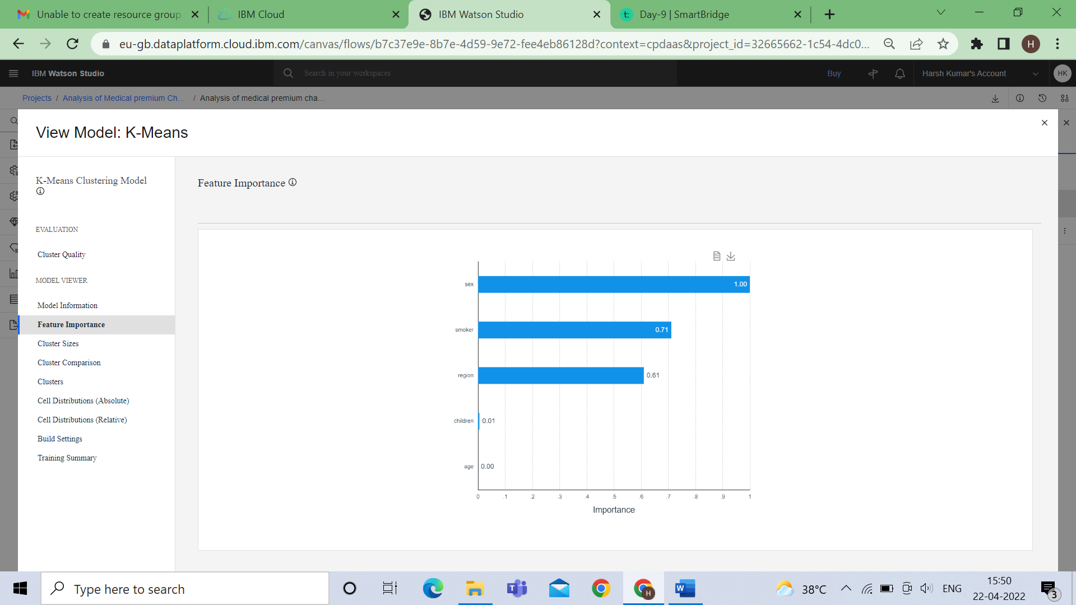

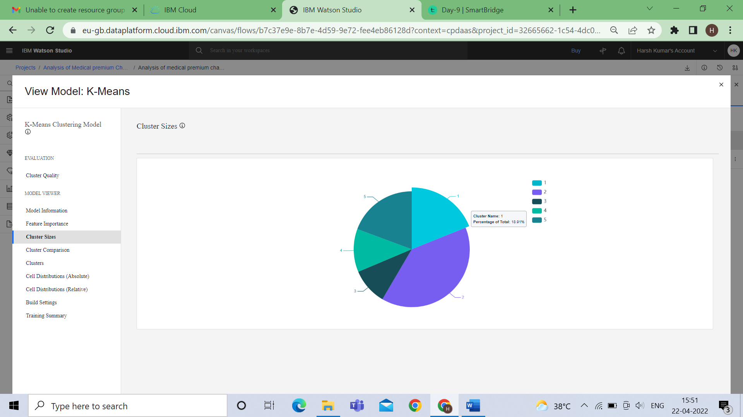

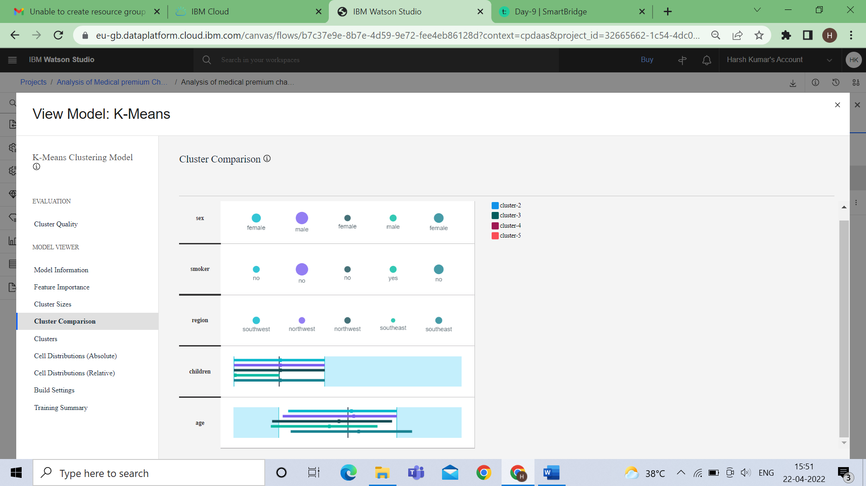

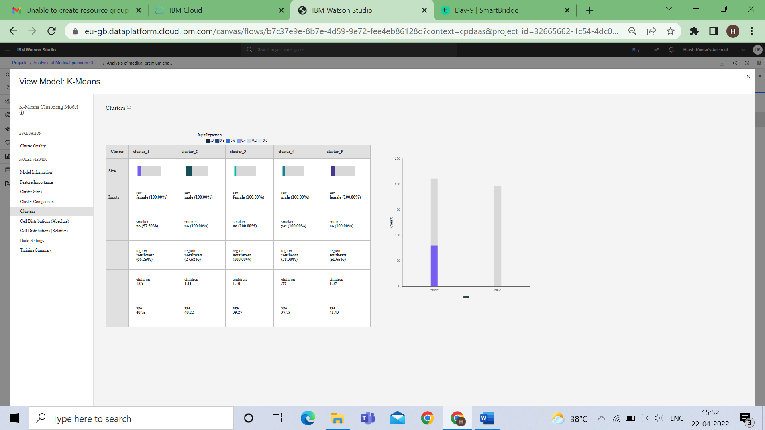

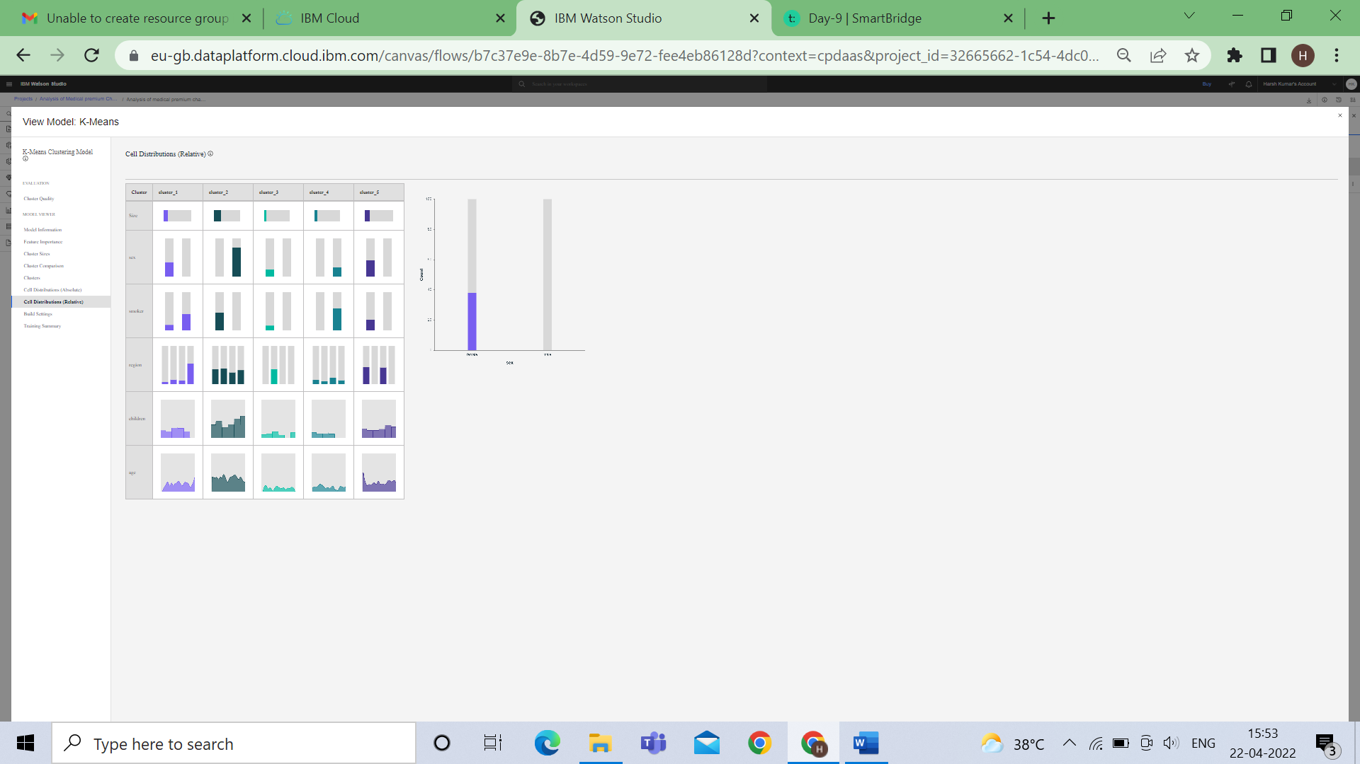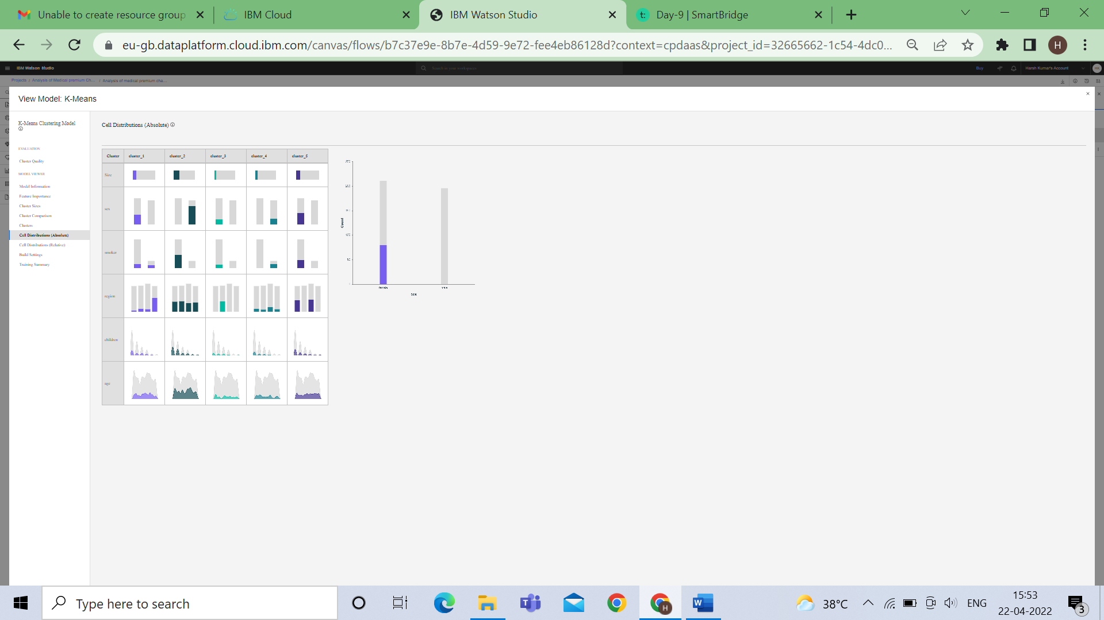

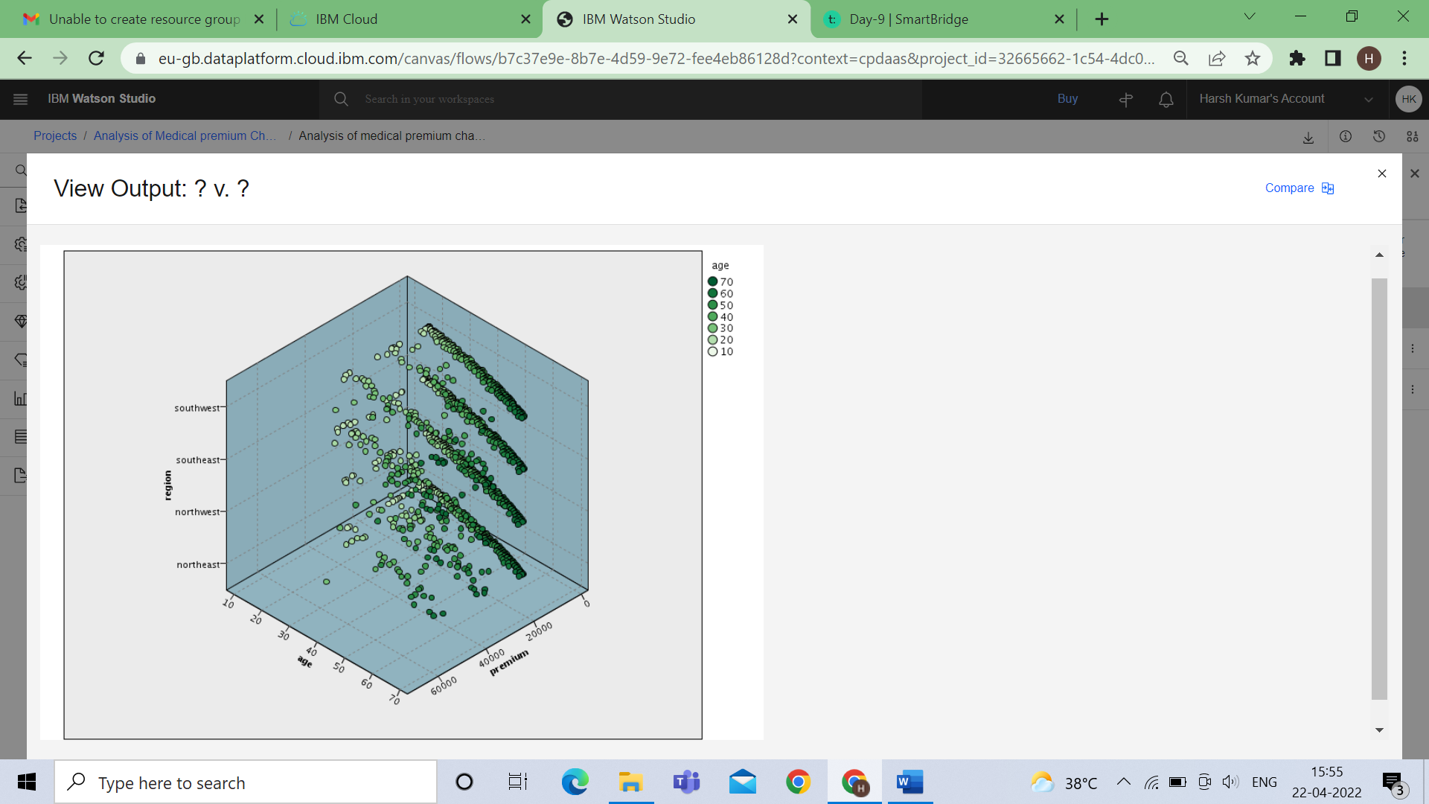

**x-axis=age , y-axis=region ,z -axis=premium**

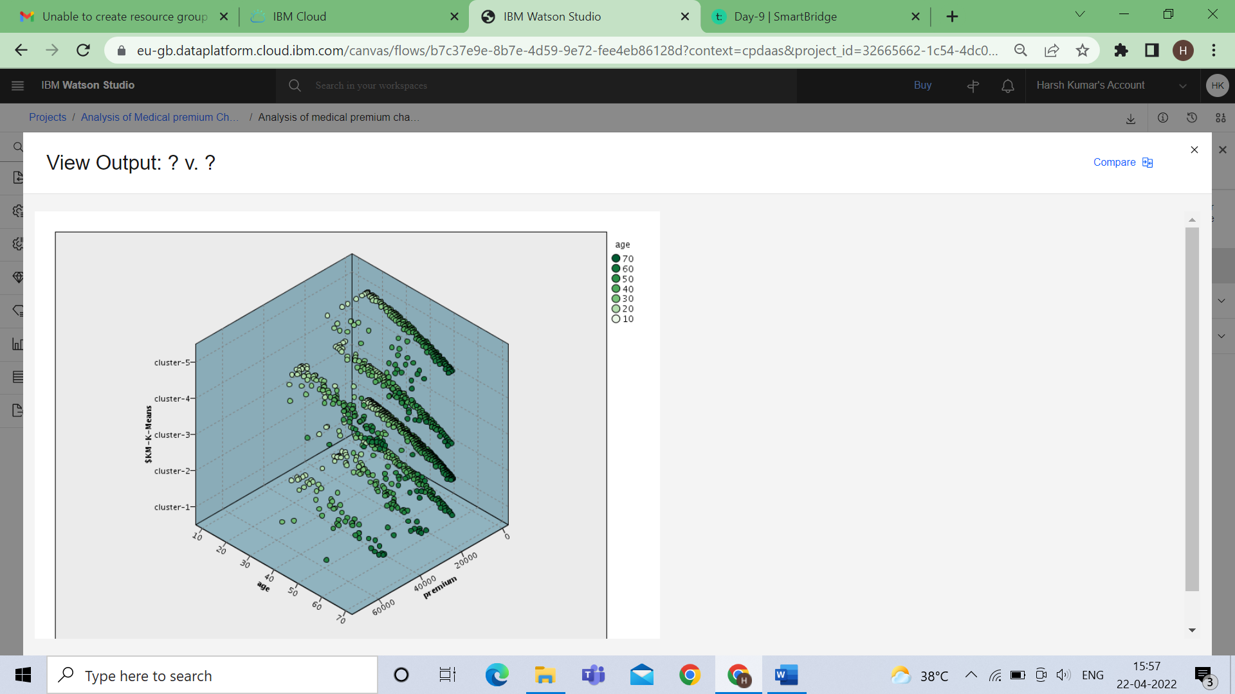

**x-axis=age , y-axis=$KM-k-Means ,z -axis=premium**

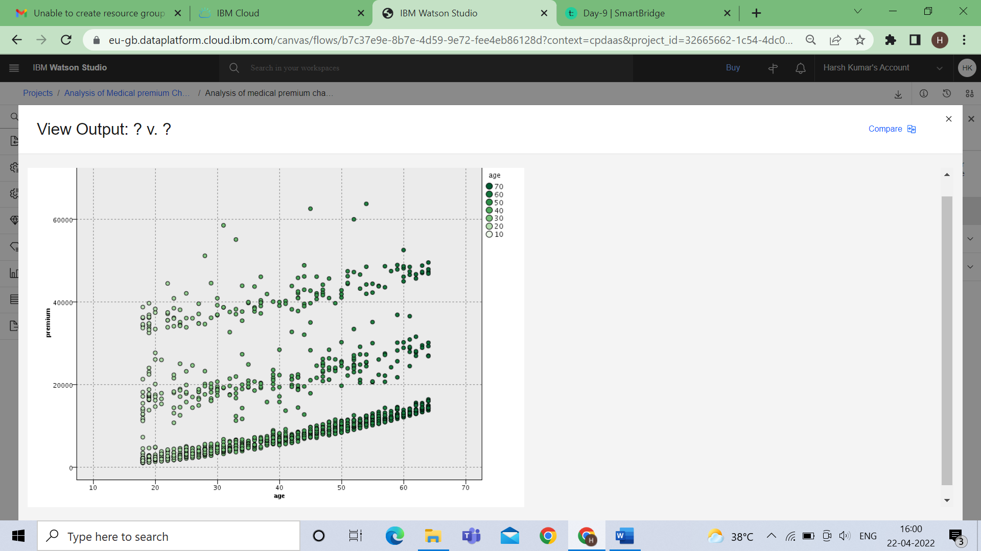

**x-axis=age , y-axis=premium**

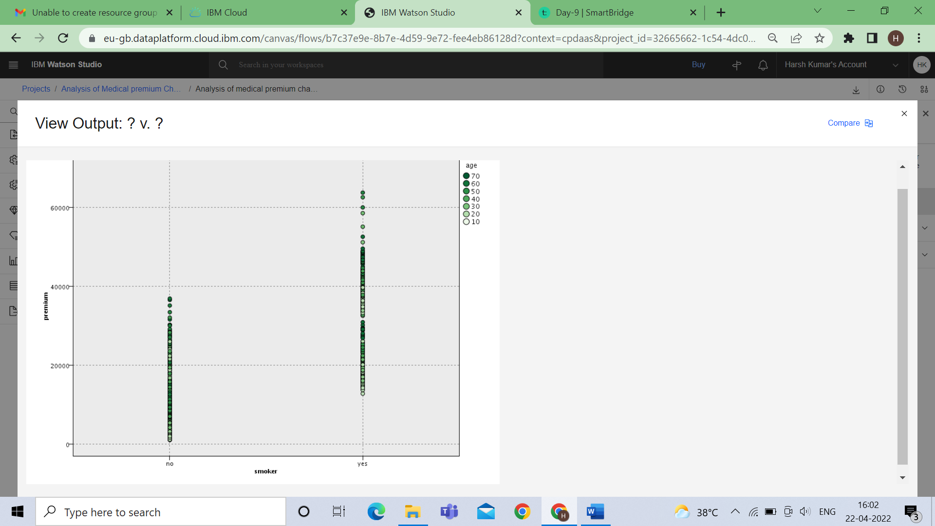

**x-axis=smoker , y-axis=premium**

* + **Data Audit**

